An **In-Memory Database**, often referred to as IMDB, is a type of database where the primary data storage resides in the computer's main memory (RAM). Unlike traditional databases that store data on disk, IMDB keeps its main copy in the computer's memory permanently.

**Advantages:** Cost-Effective RAM Expansion, Multicore Processor Efficiency (Multiple tasks executed Simultaneously = efficiency), 64-Bit Computing Performance (use large amt of main memory without sacrificing performance), Swift Query Responses.

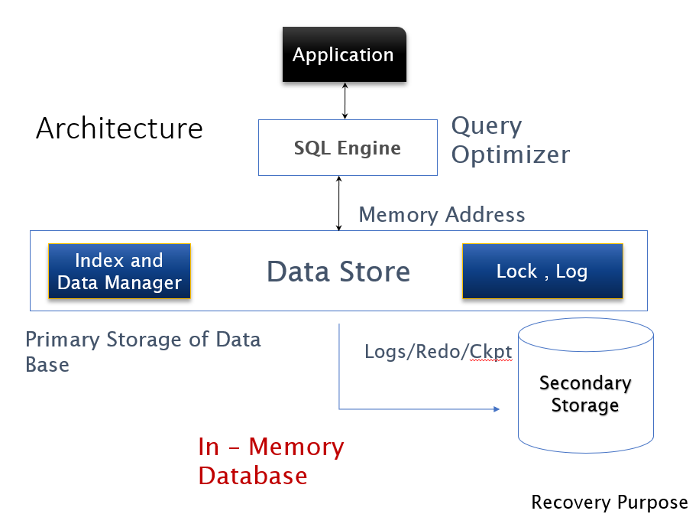

**Architecture of IMDB:-**

1. Elimination of Disk Access:

Unlike traditional databases that rely on disk storage, IMDBs store and manipulate the entire database in main memory.

This eliminates the need for accessing data from disks, which tend to be slower compared to main memory.

1. Speed of Main Memory Access:

This speed difference is crucial for applications that require quick data retrieval and processing.

1. Difference in Disk & Main Memory Access:

Disks have a fixed cost per access, regardless of the amount of data retrieved.

Main memory access is not block-oriented like disk access, making it more efficient for random access.

1. Importance of Data Layout:

The layout of data on disks is critical due to the speed advantage of sequential access.

However, sequential access is less important in main memory, allowing for simpler data structures and faster execution of requests.

1. Simplified Design and Execution:

IMDBs simplify buffer pool management and reduce the number of machine instructions needed for data retrieval and manipulation. The design becomes more straightforward and compact, resulting in faster execution of database operations.

1. Use of Secondary Storage:

While the primary data resides in main memory, IMDBs may still utilize secondary storage for tasks like writing logs and checkpoints.

**Applications:-**

1. High-Speed Data Access:

IMDBs are vital for industries requiring swift data access and manipulation, like finance for quick analysis.

1. Real-Time Embedded Systems:

Used in embedded systems for instant data responses, benefiting industries such as telecommunications.

1. MP3 Players and Set-Top Boxes:

IMDBs manage music databases in MP3 players and programming data in set-top boxes, ensuring quick navigation and presentation.

1. E-commerce and Social Networking:

Essential for e-commerce and social networking sites, enabling rapid access to user profiles and product data.

1. Financial Services:

In finance, they handle large transaction volumes in real-time for analysis & fraud detection.

1. Versatile Applications:

They serve logistics, healthcare, gaming, & scientific research, wherever rapid data processing is vital.

| **Feature** | **Data Resident Database** | **In-Memory Database (IMDB)** |
| --- | --- | --- |
| Primary Data Storage | Disk storage (HDD/SSD) | Main memory (RAM) |
| Data Access | Reads data from disk into memory when needed | Data resides permanently in memory |
| Performance | Slower data access and processing due to disk I/O latency | Faster data access and processing without disk I/O latency |
| Durability | Emphasizes durability and consistency through disk-based transactions | May require additional measures for durability, such as periodic snapshots or logging to persistent storage |
| Suitable For | Applications where data persistence and durability are critical, handling large datasets | Real-time applications, high-speed transactions, and scenarios requiring rapid data processing |
| Examples | MySQL, PostgreSQL, Oracle | CSQL, HyperSQL, VoltDB, Mcobject, MonetDB |
| Use Cases | Traditional enterprise databases, data warehousing | Real-time analytics, financial trading systems, gaming, caching, session management |
| Data Representation | Flat files, sequential access | Relational rows with pointers, space efficient |
| Concurrency Control | Low-level locking granules | Coarser locks like relation or entire database |
| Data Access Methods | B-tree index structure, disk-based | T-tree index structure |
| Query Processing | Minimizing disk access costs | Considering cardinality, presence of index, ORDER BY clause |
| ACID Properties | Supports full ACID properties | May lack durability |
| Recovery Mechanisms | Logging, checkpoints, reloading | Synchronized copies, on-disk log files |

**Challenges in IMDB:-**

1. *Durability:*

The ability of the database to withstand system failures while preserving committed transactions. Since IMDBs primarily store data in volatile memory (RAM), the risk of data loss in the event of a power outage or system crash is higher compared to disk-based databases. To address this challenge, IMDBs employ mechanisms such as checkpoints, transaction logging, and Non-Volatile RAM (NVRAM) to persist data changes and ensure recoverability.

1. *Query Optimization:*

Despite the high-speed data access and processing capabilities of IMDBs, query optimization remains a challenge. Optimizing queries involves efficiently utilizing available indexes, minimizing data movement, and selecting appropriate execution plans to retrieve data quickly. IMDBs must implement sophisticated query optimization techniques to maintain their performance advantages over traditional disk-based databases.

1. *Size of Database:*

The size of the database is another challenge for IMDBs. While modern hardware allows for large amounts of RAM, the cost and practical limitations of scaling up memory may restrict the size of the database that can be accommodated entirely in memory. IMDBs must efficiently manage memory resources and implement techniques such as data compression and partitioning to handle large datasets within the available memory footprint.